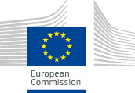 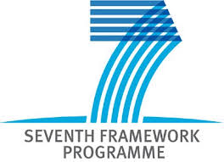….

RESULTS OF THE JRC-SCAR BIOECONOMY SURVEY

Including national report for Germany

January 2015

Author:

J.W.A. Langeveld

Project: Bioeconomy Information System
and Observatory Project (BISO)
Set up of the Bioeconomy Observatory
FP7 Grant Agreement N° 341300
Duration: 01/03/2013 – 29/02/201

Disclaimer:

The information and views set out in this study and those of the authors do not necessarily reflect the official opinion of the Commission. The Commission does not guarantee the accuracy of the data included in this study. Neither the Commission nor any person acting on the Commission’s behalf may be held responsible for the use which may be made of information contained therein.

Langeveld, J.W.A. (2015): Results of the JRC-SCAR Bioeconomy survey

STATUS: PUBLIC
This report has been prepared by:

J.W.A. Langeveld
Biomass Research
P.O. Box 247
6700 AE Wageningen
The Netherlands
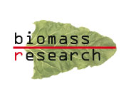

This project has received funding from the European Union’s Seventh Framework Programme for research, technological development and demonstration under Service Contract n° CCR.PSR.B182795 (Technical assistance for the realisation of a "Member State survey" for the EU Bioeconomy Observatory.)

RESULTS OF THE JRC – SCAR BIOECONOMY SURVEY

BIOMASS RESEARCH REPORT 1501

Bibliographical data:

J.W.A. Langeveld – Biomass Research

STATUS: PUBLIC

Publications available from https://biobs.jrc.ec.europa.eu/

© Copyright, Biomass Research, Wageningen

Biomass Research  P.O. Box 247  6700 AE Wageningen | T: +31 (0) 6 520 58 537  info@biomassresearch.eu  www.biomassresearch.eu

Table of contents

1. INTRODUCTION 5
2. METHODOLOGY AND QUESTIONNAIRE 9
3. RESULTS 11
Survey participation 11
Question 1: Bioeconomy policy and definition 12
Question 2: Drivers to implement a Bioeconomy policy 12
Question 3: National policy strategies 13
Question 4: Bioeconomy related R&D programmes 14
Question 5: Case-studies of Bioeconomy related research and innovation projects 15
Question 6: Bioeconomy transnational R&D collaboration 15
4. DISCUSSION AND CONCLUSION 19
ANNEXE 22
DE - GERMANY 23

- INTRODUCTION
Unprecedented and unsustainable exploitation of natural resources, potentially irreversible changes in the global climate and the lack of ability to stop the loss of biodiversity form a serious threat to the biological basis of the European society. Over the next decades, the global population is expected to increase to exceed 9 billion in 2050. These complex and inter-connected challenges will need to be addressed by an integrated and effective policy combined by an extended programme for scientific research and innovation in order to facilitate sustained changes in lifestyle and resource use across all levels of the economy.

In order to be able to cope with increasing global population, (over)exploitation of natural resources, increasing environmental pressure and climate change, Europe has to change the way it is organising the production, consumption, processing and recovering of its biological feedstocks. The bioeconomy has been proposed as a key element of a smart and green development path. Advancements in bioeconomy research and innovation uptake will facilitate the improved management of biological resources and the opening and development of diverse food and bio-based markets.

Bioeconomy has been defined in the European Commission's COM(2012)60 as:
‘‘The bioeconomy encompasses the production of renewable biological resources and their conversion into food, feed, bio-based products and bioenergy. It includes agriculture, forestry, fisheries, food and pulp and paper production, as well as parts of chemical, biotechnological and energy industries. Its sectors have a strong innovation potential due to their use of a wide range of sciences (life sciences, agronomy, ecology, food science and social sciences), enabling and industrial technologies (biotechnology, nanotechnology, information and communication technologies (ICT), and engineering), and local and tacit knowledge’’

There are many possible reasons for a country to engage in the Bioeconomy. Driving forces for Bioeconomy policy may be merely political – to realise policy existing or newly defined objectives, economic – to stimulate existing economic performance, and/or to generate new market power, as well as oriented towards realisation of environmental objectives – for example, to reduce waste, or Greenhouse Gas emissions, and help improve environmental quality.

Bioeconomy is the field where all types of biomass uses are coming together and links to all biomass uses may be found (Figure 1.1). The actual link between different sectors in practice is, however, relatively small. In the connecting field, competition may occur between biomass generating sectors – which, in principle, may be mutually replacing each other – and biomass converting sectors – which may compete for available feedstocks.

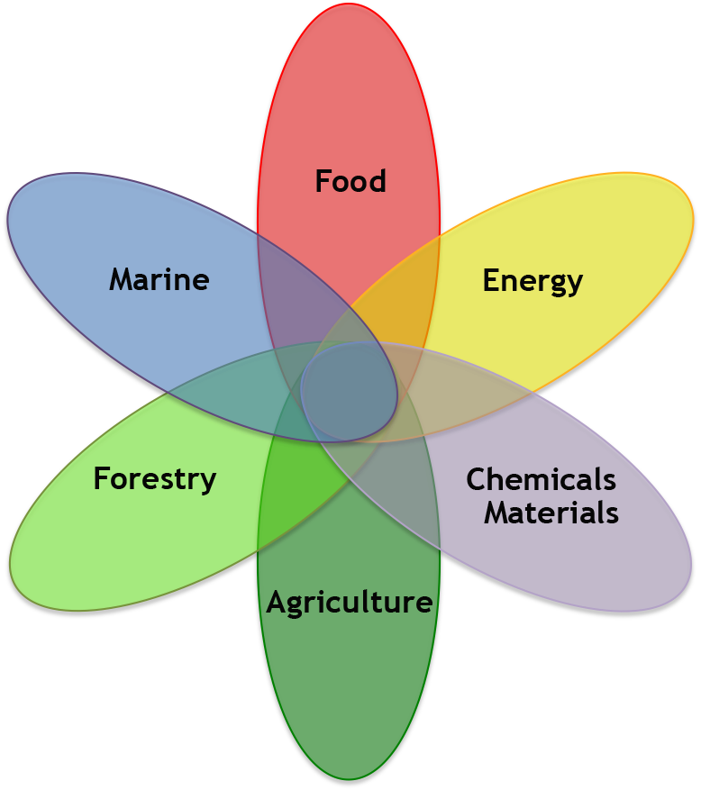
Figure 1.1. Fields covered in the Bioeconomy
Source: European Commission (2014)

All Bioeconomy areas already have their own strategy, actions and innovation. Focussed action in research and policy is needed to use them to address major basic challenges that are prevalent in the current research and policy agenda’s. By using a cross-sectoral approach, bioeconomy areas can be linked in an effective way to develop new, innovative research areas, and enhance policy coherence. The development of a good connectivity between individual areas is a prerequisite for effective bioeconomy development.

Establishing a bioeconomy can boost economic growth and jobs in rural, coastal and industrial areas, reduce fossil fuel dependence and improve the economic and environmental sustainability of primary production and processing.

The Bioeconomy Strategy and Action Plan presented in a 2012 Communication on Bioeconomy aims to facilitate the development of an innovative, resource efficient, sustainable and competitive use of biological resources, reconciling their exploitation for industrial purposes with food security while providing sufficient environmental safeguards. Under Action N° 6 of the Bioeconomy Action Plan consists in establishing a Bioeconomy Observatory.

The establishment of the Observatory is part of the implementation of the EU Bioeconomy Strategy and Action Plan laid down in the European Commission Communication on Bioeconomy of February 2012 (COM(2012)60). Objective of the action plan is to emphasise the importance of the bioeconomy for Europe in addressing major societal and economic challenges and to create a more favourable environment for its realisation.

The Bioeconomy Observatory, as the Strategy does, focuses on three main pillars (Figure 1.2):
- "Research" (investments in Research, Innovation and Skills)
- "Policy" (reinforced policy interaction and stakeholder engagement)
- "Markets" (enhancement of markets and competitiveness in bioeconomy)

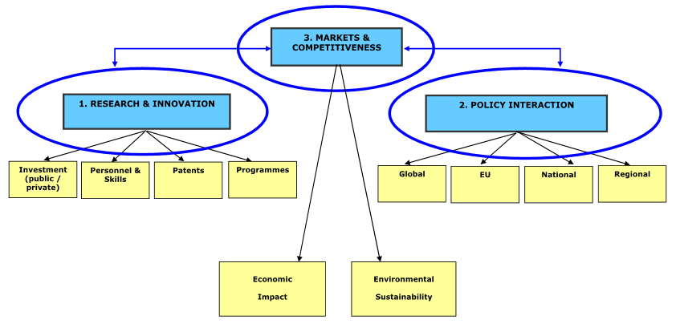
Figure 1.2 Three pillars of the Bioeconomy Information System Observatory (BISO) project

The Joint Research Centre (JRC) is in charge of setting up the Bioeconomy Observatory, in close collaboration with existing information systems that allows the Commission to regularly assess the progress and impact of the bioeconomy and develop forward-looking and modelling tools. The project time line goes from the first quarter of 2013 until the first quarter of 2016; the project acronym is BISO (Bioeconomy Information System Observatory).

The establishment of the Bioeconomy Observatory is expected to support one of the major objectives of the EU Bioeconomy Strategy, which is "to contribute to achieve the full potential of the bioeconomy, by providing the knowledge base for a coherent policy framework and promoting relevant innovation activities, thereby giving specific support to markets and policies related to the bioeconomy".

Data collection and data analysis from the Bioeconomy Observatory will provide a solid basis for decision-making on the bioeconomy, in particular for policy-makers. The primary target audience for the Bioeconomy Observatory will be policy-makers (be it at EU or at national Member States level), who will be provided with comprehensive and authoritative data and information on bioeconomy.

Data and information collected about bioeconomy research, policy and markets will be available on-line through the BISO website. More specifically, key bioeconomy data and information collected at national level are summarised in a series of "national bioeconomy country profiles" for the EU-28 Member States which can be downloaded from the website (https://biobs.jrc.ec.europa.eu/policy).

In this way, Member States authorities are provided with comprehensive and authoritative data and information on bioeconomy. They are also key partners for the Observatory in terms of "supply" of national bioeconomy data and information to the Bioeconomy Observatory. In order to access, collect and confirm the accuracy of bioeconomy data and information gathered at national level, partnership between the Bioeconomy Observatory and the Member States remains crucial.

Partnership between the Bioeconomy Observatory and the Member States has been established through bilateral interaction with individual Member States authorities and through cooperation with the Standing Committee on Agricultural Research (SCAR) and in particular its Strategic Working Group on Sustainable use of Bio-resources for a Growing Bioeconomy (SBGB).

The Standing Committee on Agricultural Research (SCAR) of the European Union was established in 1974 by a Regulation of the Council of the EU. It is formed by representatives of Member States, and presided over by a representative of the Commission, who has a mandate to advise the Commission and the Member States on the coordination of agricultural research in Europe. It was given a renewed mandate in 2005 to play a major role in the coordination of agricultural research efforts across the European Research Area.

The Membership is composed by the 28 EU Member States, as well as representatives from Candidate and Associated Countries as observers. The SCAR members currently represent 37 countries. Since 2005, more than 20 working groups have been set up by European countries engaging voluntarily and on a variable-geometry basis in the definition, development and implementation of common research agendas based on a common vision of how to address major challenges in the field of agricultural research.

In 2013, SCAR and DG-JRC decided to join forces in the development of a survey to collect essential data on national Bioeconomy policies, legal status of Bioeconomy development and national as well as regional/cluster R&D initiatives and public R&D funding. Together, DG-JRC and SCAR could provide a broad link to existing policies as well as R&D practices in the field of both classical and emerging Bioeconomy sectorial developments.

The common "Bioeconomy Member States survey" was run in 2014 aiming to collect information on the bioeconomy at individual national Member State level, with a particular focus on national research activities and policy initiatives for the bioeconomy. Biomass Research has provided support in the implementation and analysis of the survey. The general objective was to collect at individual Member State level and (on the basis of a preliminary questionnaire prepared by the JRC and SCAR) quantitative data and qualitative information on bioeconomy. In the survey, there was a particular focus on national bioeconomy research activities and national bioeconomy policy initiatives.

Biomass Research has worked in close collaboration with both the DG JRC and SCAR, in particular with the chair of its Strategic Working Group on Sustainable use of Bio-resources for a Growing Bioeconomy (SBGB). Data and information have been collected through "national survey contact points" who received (and often returned) a questionnaire. The current report presents an overview of the main results of the survey, as they have been used to be incorporated to national files presented on the Bioeconomy Observatory website. It contains the following elements: the questionnaire is introduced in Chapter 2; main results of the survey are presented in Chapter 3, which is followed by a discussion (Chapter 4). The annex lists details of the survey received from Germany. The full report, presenting results for more than 20 countries, is available online.

- METHODOLOGY AND QUESTIONNAIRE
A questionnaire was developed including six questions and several sub-questions, organised in two sections. In the first section, questions were oriented towards existence and character of national Bioeconomy policies. The second section focused on national Research and Development.

An overview of the questions is presented in Table 2.1. Many questions were open or offering plenty room for explanation and additional descriptions. Priority rankings were asked related to the main drivers to engage in the Bioeconomy (Question 2) and to the perceived benefits of research cooperation initiatives in the EU (Question 6). National policies, existing Bioeconomy regions and clusters and R&D projects could be listed. Question 4 requested annual public funding budgets for different types of Bioeconomy related research.

Table 2.1 Overview of questions of the JRC-SCAR Bioeconomy survey
Question | Subject | Type
1 | Definition of Bioeconomy implemented in national policy documents. Comparison to definition used by the European Commission | Open
2 | Main drivers to engage in the Bioeconomy | Priority ranking
3a | National policy strategies covering Bioeconomy | Yes/no + explanation
3b | Identification of national Bioeconomy policies | Yes/no + description, links
3c | Bioeconomy regions and clusters | Listing
4 | Bioeconomy R&D programmes | Listing + explanation, public budget
5 | Bioeconomy research and innovation projects | Listing + description
6 | Benefit of European research cooperation | Ranking + listing existing programmes

An overview of the questionnaire is presented in Annexe 1.

The survey and a first draft of the questionnaire were presented to members of the SCAR Strategic Working group on Sustainable Bioresources for a Growing Bioeconomy, during its meeting in the Hague on June 13, 2014. Feedback on the preliminary setup was received and elaborated in the process of the finalisation of the questionnaire.

The final questionnaire was sent out to national SCAR contact points together with a personal introduction letter on June 20. The intended first deadline was August, 15. This deadline was later extended to September, 1, 2014. An overview of the contact points involved in the survey is presented in Annex 2.

Submissions were received from Belgium, Switzerland, Czech Republic, Germany, Denmark, Estonia, Spain, Finland, France, Hungary, Ireland, Israel, Italy, Latvia, the Netherlands, Norway, Sweden, Slovenia, Turkey and the United Kingdom. Belgium submitted two questionnaires, one for each major region. Italy used the framework for an old questionnaire. The questionnaire by Latvia was received late.

- RESULTS

Survey participation
A total of 21 countries responded to the survey (Figure 3.1). Of them, 20 submitted a questionnaire, 17 Member States (Belgium, Czech Republic, Germany, Denmark, Estonia, Spain, Finland, France, Hungary, Ireland, Italy, Latvia, the Netherlands, Sweden, Slovenia, and the United Kingdom), and four non-Member States (Switzerland, Israel, Norway, and Turkey). One country (Slovak Republic) announced that submission was intended. Belgium submitted two questionnaires, one for Flanders and one for Wallonia.
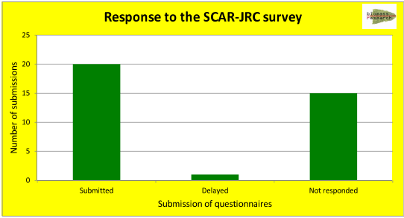
Figure 3.1 Questionnaire submission

Not all questionnaires were complete. Italy used an old format, and did not provide answers to all questions. Other countries missed questions as well (Figure 3.2).

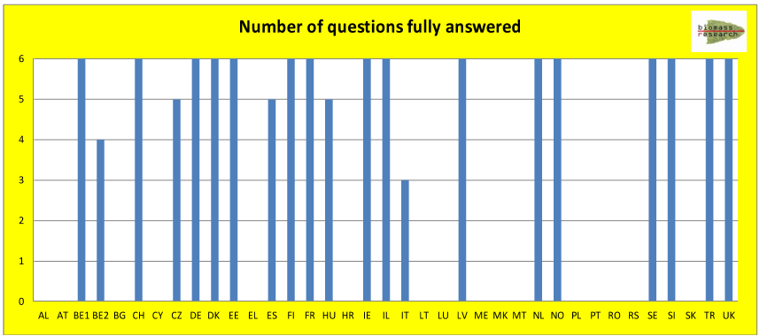 Figure 3.2 Number of questions that were fully answered

Question 1: Bioeconomy policy and definition
Twelve countries (60%) use a definition for the Bioeconomy that is more or less similar to the definition used by the European Commission (Figure 3.3). Among Member States that submitted the questionnaire, ten (63%) have a similar definition to the one used by the Commission. Most of the other countries do not use a definition.
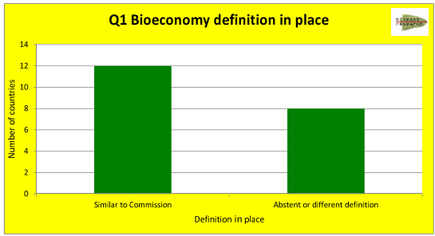
Figure 3.3 Bioeconomy definition resemblance with the Commission’s definition

Question 2: Drivers to implement a Bioeconomy policy
Reasons to implement Bioeconomy policy are related to factors with a merely political, economic, or environmental character. The average ranking of 20 submissions shows priority of individual drivers ranges between 3.0 and 4.5. Economic drivers are given a higher average score (4.3) than political (average score 3.7) and environmental objectives (average 3.5). Hence, the development of a Bioeconomy policy is seen as an opportunity to enhance economic development, including both classic and new Bioeconomy sectors, while food security and the need to combat climate change are also relevant (Figure 3.4).

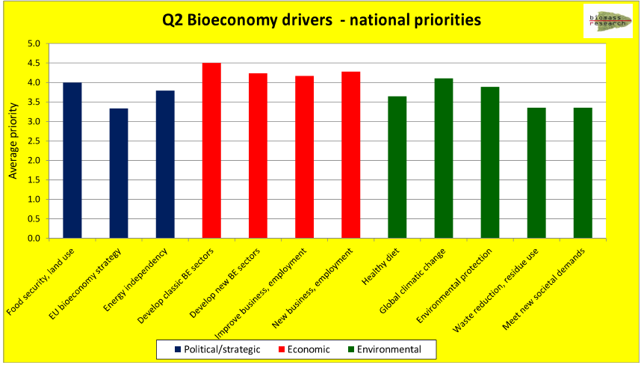
Figure 3.4 Drivers to develop a Bioeconomy strategy

Question 3: National policy strategies
Nine countries are implementing a Bioeconomy strategy (Figure 3.5). Flanders, Germany, Finland and Sweden have developed a full strategy; Switzerland, Denmark, Estonia, the Netherlands and Wallonia implement a partial strategy.

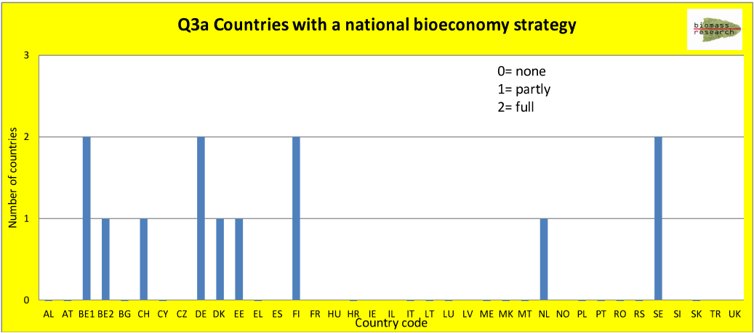
Figure 3.5 Countries with a Bioeconomy strategy

Five countries (Germany, Estonia, Finland, Hungary and the Netherlands) have installed a national Bioeconomy Agency. In most cases, two ministries are (jointly) in charge of the implementation of the Bioeconomy strategy (Figure 3.6).

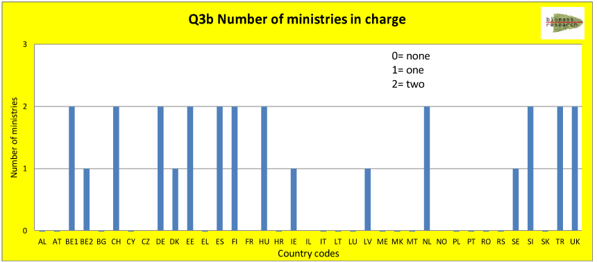
Figure 3.6 Number of ministries in charge of the Bioeconomy strategy

Question 4: Bioeconomy related R&D programmes
The budget for R & D programmes in the bioeconomy receives some 2.3 billion of public funds. This amount is based on the questionnaires that were submitted and cannot be considered as fully representative for countries that did not submit any details on their information. Details of the funding of bioeconomy research & development programmes are presented in Table 3.1. Agriculture is the sector receiving most of the R & D funding. It annually receives 1.3 billion Euro which is more than half of all reported public funding. Industrial use of biomass receives 185 million Euro’s (8%); while 185 million Euro is allocated to energy use; marine, fisheries and aquaculture receive 172 million Euro’s (7%). A relatively small amount is designated to generic bioeconomy programs (6%).

Table 3.1 Bioeconomy related national research budgets
Sector / activity | Budget ¹ | Share of total budget ²
Generic Bioeconomy ª | 136 | 5.8%
Agriculture | 1,344 | 57.5%
Forestry | 10 | 0.4%
Marine, fisheries, aquaculture | 172 | 7.4%
Waste as biomass sources | 58 | 2.5%
Food and feed use of biomass (food/feed value chains) | 27 | 1.2%
Energy use of biomass (bioenergy) | 185 | 7.9%
Industrial uses of biomass ^{b} | 196 | 8.4%
Key enabling technology (industrial biotechnology) | 54 | 2.3%
Communication, stakeholder involvement | 0 | 0.0%
Other (please specify) | 155 | 6.6%
All | 2,338 | 100.0%
ª Covering several elements and sectors of the bioeconomy; ^{b} Including paper and pulp, wood and wood products, chemical production, pharmaceutical production, and other industrial uses.

Question 5: Case-studies of Bioeconomy related research and innovation projects
More than 100 case-studies of successful Bioeconomy development have been reported. Nearly half of them were listed by Germany. Large numbers of case-studies were also reported by Flanders, Germany, Denmark and the UK. An overview of the number of case studies reported is given in Figure 3.7.
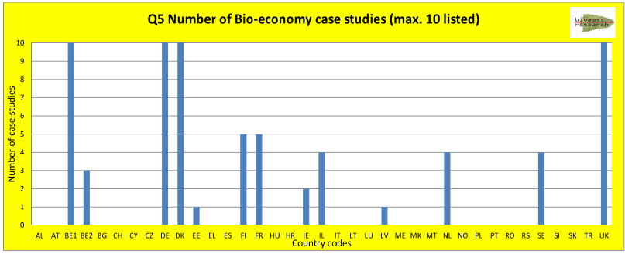
Figure 3.7 Number of case studies reported

Question 6: Bioeconomy transnational R&D collaboration
The participating countries see large (potential) benefits of participation in international R&D programmes related to the Bioeconomy, although in many cases countries find it difficult to assess priority. Table 3.2 presents an overview of rankings allocated to individual elements. The lowest ranking (1) was not given. Most frequent were the highest rankings (4 and 5).

Table 3.2 Rankings reported on perceived benefits of transnational R & D collaboration
Ranking  Sector / activity | 1 | 2 | 3 | 4 | 5 | All
Food security | 0 | 1 | 0 | 6 | 6 | 13
Policy framework | 0 | 0 | 2 | 5 | 3 | 10
Bioenergy | 0 | 0 | 5 | 2 | 4 | 11
Social inclusion | 0 | 0 | 4 | 2 | 2 | 8
Economic, market framework | 0 | 0 | 3 | 3 | 5 | 11
Knowledge, practices transfer | 0 | 0 | 1 | 8 | 4 | 13
Resource efficiency | 0 | 0 | 2 | 5 | 5 | 12
Biorefineries | 0 | 1 | 2 | 4 | 4 | 10
Algae | 0 | 1 | 2 | 2 | 1 | 11
Animal feed | 0 | 1 | 4 | 5 | 0 | 6
Healthy food research | 0 | 1 | 1 | 5 | 5 | 12
Sustainability criteria | 0 | 0 | 1 | 3 | 9 | 13
Genetics | 0 | 1 | 2 | 5 | 4 | 12
Renewable resources | 0 | 1 | 3 | 3 | 4 | 11
Footprint methodology | 0 | 1 | 1 | 3 | 3 | 8
All | 0 | 8 | 33 | 63 | 61 | 4

Average ranking scores per element were high, ranging between 3.5 and 4.6. Highest scores were given to research on the development of sustainability criteria, and to research on biorefineries, food security, resource efficiency and knowledge transfer (Figure 3.8). Average scores for political/strategic and economic elements were similar (4.1). Scores for environmental elements were slightly higher (4.2).

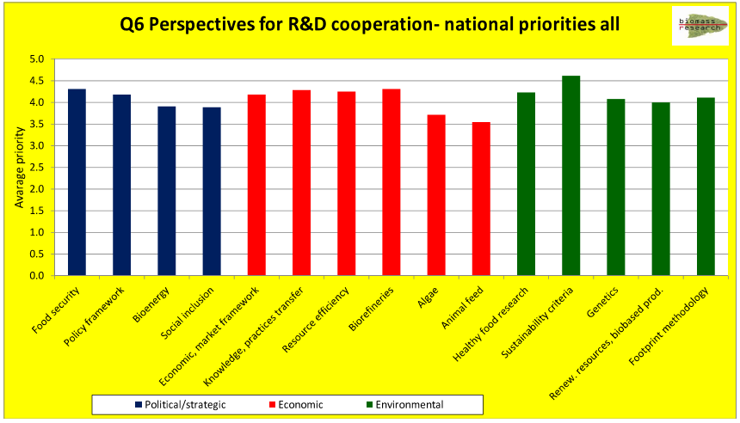
Figure 3.8 Perspective for international cooperation (all submissions)
A comparison between scores of Member States and non-Member States shows few differences. Member States generally give higher rankings, which suggests higher expectations of international cooperation. Environmental elements are given the highest ranking (Figure 3.9).

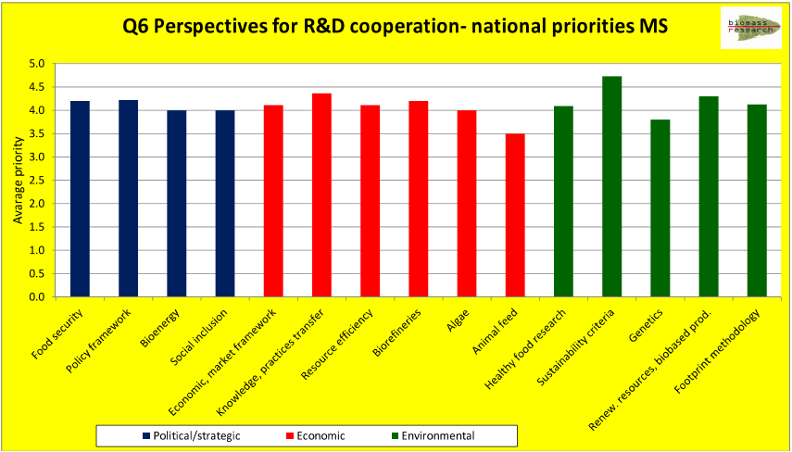 Figure 3.9 Perspective for international cooperation (Member States only)

- DISCUSSION AND CONCLUSION
Following an active policy towards the development of a strong and effective Bioeconomy in the EU, the European Commission is working towards the establishment of a Bioeconomy Observatory. The development of the BISO project is supported by a "Bioeconomy Member States survey" to collect information on the bioeconomy at individual Member State level national, with a particular focus on national research activities and policy initiatives for the bioeconomy. A SCAR (Standing Committee on Agricultural Research) member list has been used to identify national contact points in 28 European nations including all EU Member States.

Each of the contact points was approached, requesting collaboration in the distribution and/or filling of the questionnaire in their home country. In most cases, the questionnaire was redirected to the responsible ministries as requested. Sometimes, a new contact point had to be approached. General response to the request was positive, with more than half of the countries submitting a questionnaire within the requested period which included the summer period of 2014.

The response was higher than previously was anticipated, which suggests that the right forum has been used to address issues of Bioeconomy Observatory. Twenty countries have submitted a questionnaire; Belgium submitted two (one for each major region). The quality of the submitted questionnaires was high, often providing a lot of details related to policy, R&D and regional initiatives.

This does not mean that all countries have provided similar quality of answers. As a rule, countries already active in the development of a Bioeconomy policy and research framework (e.g. Germany, Denmark, Finland, Belgium, and The Netherlands) made a larger effort in preparing the answers to the survey. While, further, the response rate has been above expectations, it is recommended to approach countries that did not (yet) submit directly as the SCAR list of contact points is not likely to be the best opportunity to obtain the missing questionnaires.

Large differences exist with respect to the implementation of a Bioeconomy policy. A limited number of countries installed such a policy, a bioeconomy advisory board or an implementation agency. In some other cases, one or two ministries have been assigned the lead in the development of a Bioeconomy policy. Generally, a small number of countries seem to implement a full package (strategy, board, agency, policies, and dedicated R&D programmes).

There is, however, room for optimism. While Bioeconomy oriented policies and R&D infrastructure are developing, both at the national and the EU level many initiatives are taken. There is a substantial budget for Bioeconomy related research, with annual expenses exceeding 2.3 billion Euro.

A large number (108) of regional/cluster or national initiatives has been listed in the survey, and more may be expected. The recent publication of National Bioeconomy Profiles in the Bioeconomy Observatory (https://biobs.jrc.ec.europa.eu/), combining data from national and EU statistical bureau’s with industrial key figures and data generated by the survey, is another milestone.

How, then, to evaluate these figures? We compare results presented above to a list of enabling factors for the development of new biotechnological innovations as presented by the Pugatch Consilium (2014). Enabling factors for innovative technological development include:

1. Human capital – A basic and fundamental building block is the availability of high skilled and technically trained human capital.

2. Infrastructure for R&D – R&D capacity is critical to fostering innovation and activity in high tech sectors including biotechnology and is reflected by country-level indicators including total R&D expenditure; patenting intensity; life science investment levels; public-private partnerships; and academic and scientific citations.

3. Intellectual property protection – Intellectual property rights such as patents and regulatory data protection are historically of real importance to the biotech and biopharmaceutical innovation process as they incentivise and support the research and development of new biological technologies and products.

4. Regulatory environment – The regulatory and clinical environment in a given country plays a significant role in shaping incentives for innovation and establishing adequate levels of quality and safety for biotech products, particularly biopharmaceuticals.

5. Technology transfer frameworks – Technology transfer is an important mechanism for the commercialisation and transfer of research from public and governmental bodies allowing private entities to develop commercially applicable technologies.

6. Market and commercial incentives – Market and commercial incentives can be realised via different formats including as tax incentives, support for basic research and R&D credits for investments in plant, equipment and other R&D infrastructure.

7. Legal certainty (including the rule of law) – The general legal environment as it relates to the rule of law including legal business context is crucial to commercialization and business activities.
Five of the enabling factors are addressed by the survey: human capital, R&D infrastructure, the regulatory environment, technology transfers, and legal certainty. Market incentives are not addressed directly, but it may be expected that emphasis on a proper legal framework and – especially – budgets for Research & Development, as well as international cooperation in R&D, help to develop an environment where economic conditions for commercial development is favourable. The survey provides a good coverage of the factors that need to be addressed in the Bioeconomy.

The recommendations presented by Pugatch with respect to technology development are in line with results of other studies. Compare, for example, to a listing by the Milken Institute (2013).
According to this study, prequisites for bioeconomy development in the USA include:
- Consistent government policies
- ‘Green banks’
- Public, private procurement programs
- Legel regulatory playing field
- Use agricultural, rural development programs
- CAP, Cohesian funds
- Use existing infrastructure

The list provided by Pugatch is also in line findings of other theoretical frameworks like the Functions of Innovation Systems Theory, that was developed for analysing the implementation of innovations in the Netherlands. As a rule, succesful innovations require a combination of availability of robust technology development, knowledge diffusion, enterpreneurship, availability of credit, market development and political frameworks (Langeveld 2010).

Not all elements are equally well covered in the JRC-SCAR survey or – more in general – the Bioeconomy Observatory. Basically, these focus on the identification of the Bioeconomy as a strategic development area, the stimulation of national Bioeconomy strategies, the measurement and evaluation of performance including the identification of best practices, the leverage of national capabilities and enhancement of international cooperation.

ANNEXE

DE - GERMANY

 | 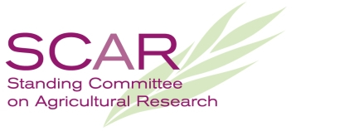  Strategic Working Group on Biomass
  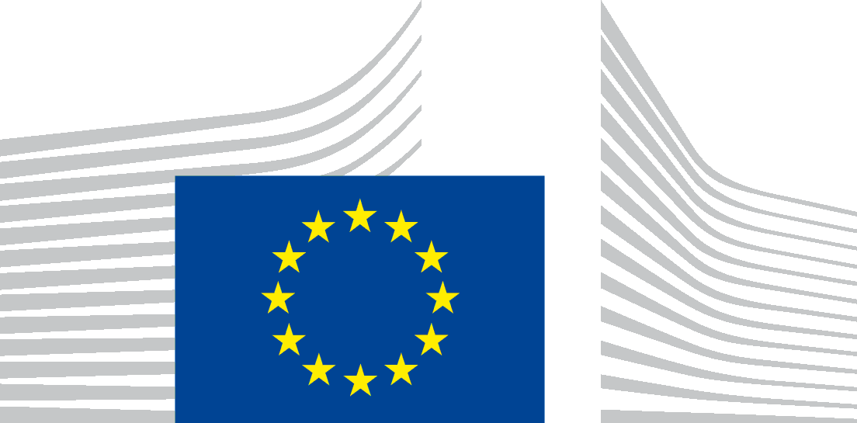 | EUROPEAN COMMISSION  JOINT RESEARCH CENTRE

Joint Survey on National Bioeconomy Strategies

Country: | Germany
Year of data collection: | reporting date: July 2014
Contact mail person in charge of data collection: | Henkvan.Liempt@bmbf.bund.de

St

This survey consist of two parts. It is aimed to collect data on:
- National Bioeconomy Policies and
- National Bioeconomy Research & Development
udy subject
I POLICY
Q 1: Does your country have a national definition for Bioeconomy? If so, please provide definition here
German Bioeconomy Definition (National Policy Strategy Bioeconomy):
“Knowledge-based production and utilisation of renewable resources in order to provide products, processes and services in all economic sectors within the framework of a sustainable economic system. The bioeconomy concept encompasses all economic sectors and their associated services, that produce, manage and otherwise exploit renewable resources – such as plants, animals and microorganisms and their products – produce, process, use or trade.”

“The “knowledge-based bioeconomy” (…) takes natural materials cycles as its point of orientation; it bases itself upon a structural transition from an economy based on finite resources of fossil origin – mainly petroleum – to an economy more strongly based on renewable resources. New knowledge gained in the life sciences and technical sciences is bringing about a deeper understanding of the global biological systems (…).
The bioeconomy spans a bridge linking technology, the economy and ecological issues, by applying biological processes and resources, further developing them and thus enhancing their performance capability, as well as making their use more efficient and sustainable. The bioeconomy not only replaces raw materials sourced from fossils; it also develops wholly new products and processes.
Bioeconomy is the knowledge-based production and use of renewable resources, in order to provide products, processes and services in all areas of the economy, within the framework of an economic system that is viable for the future.
The concept of the bioeconomy encompasses all economic sectors and their associated commercial services, involved in producing, working or processing, using or trading with renewable resources – such as plants, animals and micro-organisms and products made from them. This is done with the aim of making it possible to effect a transition to running the economy in a way that is increasingly independent of petroleum. Thus the knowledge-based bioeconomy can be an essential part of a viable and sustainable economic system. Agriculture, forestry, fisheries, and aquaculture, but also the biotechnological use and conversion of biomass, in addition to biogenic waste materials and residual materials: these are the central starting points for the bioeconomy‘s value chains and value adding networks, which are interlinked in a multitude of ways. Downstream sectors work and process renewable resources to form a variety of products, partly also through industrial application of biotechnological and microbiological processes, particularly in the chemical industry. This also includes food producers, and the wood, paper, construction, leather, and textile industries, as well as parts of the pharmaceutical industry and the energy sector. To that extent they are as involved in the build-up of a bioeconomy as are the associated areas of retail, distribution and commercial service sectors. It is characteristic of the bioeconomy, firstly, that the value chains of its products in the various business sectors are increasingly networked, or respectively are able to be networked, and secondly that by-products and residual materials are used in a way that yields the highest possible value. Accordingly, the bioeconomy system also attaches particular significance to recycling and waste-management processes that can avoid residual materials and waste materials, or respectively direct them to a use that derives the highest possible value from them.”
(http://www.bmel.de/SharedDocs/Downloads/EN/Publications/NatPolicyStrategyBioeconomy.pdf?__blob=publicationFile)

Please describe where your country’s definition is different from the EU definition of the bioeconomy.

The German and European Bioeconomy definitions are - to a large extent - in good agreement. Both definitions address biomedicine or red biotechnology – in contrast e.g. to the OECD and US definitions of bioeconomy - only to a limited extend and put a strong focus on a recycling economy, that prioritizes the use of renewable resources for safeguarding food supplies and aims to create synergies between the use of renewable resources for food, material- and energetic use. The German definition as well as the goals of the German National Policy Strategy on Bioeconomy are driven by the principle that only a sustainable bioeconomy may contribute to master global challenges like providing food for a growing mankind and the protection of the climate and conservation of the biodiversity.

“The concept of the bioeconomy takes natural cycles of materials as its point of orientation; it encompasses all sectors of the economy that produce, work and process, use, and trade with renewable resources, such as plants, animals, micro-organisms, and their derivatives. Materials used include not only raw materials produced in the agricultural, forestry and fisheries sectors, as well as in aquaculture or in microbial production; increasingly, biogenic waste materials and residual materials are also used. The bioeconomy is thus also resource-efficient recycling. The renewable resources are worked and processed to form a variety of products, also increasingly by means of industrial application of biotechnological and microbiological processes. Aside from its use for the production of materials, the use of sustainably produced biomass also acts as a significant renewable source of energy – with preference given to using it at the end of the cascading process of use.“

I POLICY
Q 2: Please list the main drivers for your country to engage in the development of the Bioeconomy
 | Please insert priority  ranging from 5 (= high) to 1 (= low) | Comment/specification
Contribution/implementation of the EU strategy on Bioeconomy |  | The EU Strategy on Bioeconomy (2012) is making an important and valuable contribution to the continued implementation of the National Research Strategy Bioeconomy 2030 and optimally complements the German National Policy Strategy Bioeconomy adopted in 2013 by the German federal government.  In the past the EU strategy on Bioeconomy was not a main driver for Germany to engage in the development of the Bioeconomy, since the German federal government started the implementation of a biobased economy already in 2009/2010, by establishing a National BioEconomy Research Strategy and a National Bioeconomy Council, respectively.
Food security/ land-use competition | 5 | “Securing global nutrition” and “Prevention or Mitigation of land-use competition” are major goals/ fields of action in the German Bioeconomy strategies.  To ensure nutrition for 9.5 billion people in 2050 – with changed consumer demands – food production must be increased significantly and the availability of foodstuffs improved for vulnerable population groups. The arable land needed for production is limited, and in many areas is above all qualitatively and quantitatively affected by soil degradation. In the long term, agriculture will also be affected to a significant extent by the effects of climate change, and will have to cope with soil deterioration, water shortages and floods, and the spread of plant pests, amongst others.
Healthy diet | 5 | “Producing healthy and safe foods” is a major goal/ field of action in the German Bioeconomy strategies.  Consumers expect healthy, high-quality, safe and at the same time inexpensive foods. Demographic change, changing lifestyles and circumstances are altering  dietary behaviour. A healthy diet presupposes a corresponding availability of food that meets individual requirements.
Independence from fossil resources/security of supply | 5 | „Using renewable resources for industry“ and „Developing biomass-based energy carriers” are major goals/ fields of action in the German Bioeconomy strategies.  Biobased products, which combine biotechnical, chemical, thermal, or mechanical methods in their manufacturing process, not only help protect nature, the environment, and the climate, but also enable greater independence from fossil raw materials. Furthermore, they make a significant contribution to the structural change from a  petroleum-based to a biobased industry with related opportunities for growth and employment. Industrial biotechnology, also known as white biotechnology, is an important driving force in this transition.  Energy from biomass will continue to gain in importance as a component of the overall energy mix. In the framework of regional health provision concepts, this can contribute to local creation of value, and to the creation of jobs in agriculture, forestry, and industry. Extensive technical research work and studies into sustainability as well as scientific monitoring of demonstration  projects and market introductions will be essential if bioenergy is to become internationally competitive. The challenge also lies in establishing modes of production and utilization that climate-, nature-, and environment-friendly. Systems should be de-signed to be efficient, sustainable, and economical along the entire process chain.
Development of classic bioeconomy sectors (agriculture, forestry, fisheries, food, paper) | 5 | “Ensuring sustainable agricultural production” is a major goal/ field of action in the German Bioeconomy strategies.  Natural resources are the means of production for the bioeconomy, and thus their sustainable management is in the highest interest. The required increase in agricultural production must be achieved by means of efficient and resource-friendly management. the implementation of this must correspond to the challenges posed by  climate change, environmental and climate protection, raw material supplies, water availability, and biodiversity protection. This also demands research efforts that take into account all the factors of agricultural production systems – for terrestrial as well as aquatic biomass production – according to specific location requirements, and allowing for aspects of sustainability.
Development of new bioeconomy sectors (bioenergy, industrial biobased products) | 5 | See above
Maintaining business base and employment | 5 | Strengthening the innovation power and the national and international competitiveness of Germany as a place for reseach-, investment and innovation as well as creating sustainable added value, are important goals/fields of action in the German Bioeconomy strategies.  Training and education are - besides the safeguarding of employment and job creation – also important topics for a successful implementation of a biobased economy.
New business, increased employment | 5 | “Growth markets, innovative technologies and products” are further major goals/ fields of action in the German Bioeconomy strategies, and provide the basis for new business models and can speed up structural change towards international competitiveness, to the development of new markets meeting among others new societal needs.
Mitigation of climate change/adaptation to climate change | 5 | Mitigation of climate change/adaptation to climate change and sustainable climate protection are major cross-sectional responsibilities addressed in the German Bioeconomy policies.
Environmental protection/ environmental sustainability (i.e. biodiversity and ecological services) | 5 | Environmental protection/ environmental sustainability, by maintaining biodiversity and soil fertility among others, are major cross-sectional responsibilities addressed in the German Bioeconomy policies.
Resource efficient economy  (reduction of waste, use of residues) | 5 | Resource efficient economy, with an emphasis on Biorefineries using all components of various plants and/or waste, as well as residual materials, is an important driver of the German bioeconomy.
Societal demand | 5 | The German bioeconomy strategies place considerable importance on the need to meet societal demands and on maintaining a dialog with the general public and  Bioeconomy has to take account of the growing societal demands concerning the question how products are manufactured.  This applies to the compliance of environment, health and animal welfare standards as well as the adherence to social standards.  Sustainable consumption is an important part of the bioeconomy value chain - Consumers will decisively influence the development of a bioeconomy. Information and transparency empower the consumers to make purchasing decisions on the basis of sustainability concerns.
Other drivers – please specify

I POLICY
Q 3A: Please list National policy strategies which would also cover the Bioeconomy at least partly
Does your country have a National Bioeconomy strategy? | Yes | Policy Strategy Bioeconomy  http://www.bmel.de/SharedDocs/Downloads/EN/Publications/NatPolicyStrategyBioeconomy.pdf?__blob=publicationFile  National BioEconomy Research Strategy 2030  www.bmbf.de/pub/bioeconomy_2030.pdf  Biorefineries Roadmap  http://mediathek.fnr.de/broschuren/fremdsprachige-publikationen/english-books/biorefineries-roadmap.html and www.bmbf.de/pub/roadmap_biorefineries.pdf
Ministry(ies) in charge of the Bioeconomy strategy? | Yes | Name of the responsible Ministry/ Ministries:  Policy Strategy Bioeconomy – under the aegis of Federal Ministry for Food and Agriculture (BMEL). Other involved ministries: Federal Ministry for Education and Research (BMBF), Federal Ministry for the Environment, Nature Conservation, Building and Nuclear Safety (BMUB), Federal Ministry of Transport and digital Infrastructure (BMVI), Federal Ministry of Economics and Energy (BMWi), Federal Ministry for Economic Cooperation and Development (BMZ)  www.bmel.de  National BioEconomy Research Strategy 2030 – under the aegis of Federal Ministry for Education and Research. Other involved ministries: Federal Ministry for Food and Agriculture (BMEL), Federal Ministry for the Environment, Nature Conservation, Building and Nuclear Safety (BMUB), Federal Ministry of Economics and Energy (BMWi), Federal Ministry for Economic Cooperation and Development (BMZ)  http://www.bmbf.de/de/biooekonomie.php  Biorefineries Roadmap – under the aegis of Federal Ministry for Education and Research and Federal Ministry for Food and Agriculture. Other involved ministries: Federal Ministry for the Environment, Nature Conservation, Building and Nuclear Safety (BMUB) and the ), Federal Ministry of Economics and Energy (BMWi)  http://mediathek.fnr.de/broschuren/fremdsprachige-publikationen/english-books/biorefineries-roadmap.html or www.bmbf.de/pub/roadmap_biorefineries.pdf
Does your country have a Bioeconomy advisory body/panel? | Yes | Name of the body:  Bioeconomy Council  http://biooekonomierat.de
Does your country have a Bioeconomy agency or agencies? | Yes | Name of the agency:  Projektträger Jülich, PtJ – Project Management Jülich  www.ptj.de  Fachagentur Nachwachsende Rohstoffe e.V., FNR – Agency for Renewable Resources  www.fnr.de  Bundesanstalt für Landwirtschaft und Ernährung, BLE – Federal Office for Agriculture and Food  www.ble.de
Does your country have a Bioeconomy observatory collecting data/info? | Under development | The Interdepartmental Working Group Bioeconomy of the Federal Government has set the objective to implement a bioeconomy monitoring project under the aegis of Federal Ministry for Education and Research
Does your country have a Bioeconomy National Contact point? | Yes | National Contact Point Life Sciences  www.nks-lebenswissenschaften.de  National Contact Point Life Sciences PtJ and PT-DLR  Joseph-Schumpeter-Allee 1  D-53227 Bonn  Tel.: +49 (0)228-3821-1697  Fax: +49 (0)228-3821-1699  Email: nks-lebenswissenschaften@dlr.de

Bioeconomy related policies  Q 3B: | Is a policy initiative for this area/sector available? | If yes, please elaborate on how the Bioeconomy is covered in this policy initiative | Link for download
Comment:
The most important strategies listed in the “Policy Strategy Bioeconomy” are specified below.
In 2014 some of the strategies are phasing out, follow up strategies are in preparation

Agriculture | Yes / No
Forestry | Yes | “Forest Strategy 2020” (2011):  Forests and forestry are more closely linked to climate than any other sector. Whilst the preservation of forests, sustainable forest management and timber use can have a positive effect on climate, climate changes can have a negative impact on the health of our forests. The release of CO2 can be avoided or reduced as a consequence of carbon storage in forests, the replacement of fossil fuels and the sequestration of carbon in long-livid timber products. | www.bmel.de/.../EN/.../ForestStrategy2020.pdf
Marine/Fisheries/Aquaculture | Yes / No
Waste | Yes | “Biorefineries Roadmap” (2012):  The ‘Biorefineries Roadmap’ makes a contribution to the German federal government strategy for the development of a bioeconomy specified in the ‘National Research Strategy Bioeconomy 2030’, the “Policy Strategy Bioeconomy”, the federal government’s energy concept and ‘National Climate Initiative’, and in the action plans for the material and energetic utilization of renewable resources.  Biorefinery concepts – as central elements of a bio-based economy, and promising largely waste-free use of biomass, efficient conversion routes, and pathways for the energetic and material use of biomass – could play an important role for a future bioeconomy in the utilization and conversion of biogenic raw materials and residues. | www.bmbf.de/pub/roadmap_biorefineries.pdf
Agri-Food & Food security | Yes / No
Food, Healthy diet | Yes / No
Research & Innovation | Yes | “National Research Strategy Bioeconomy 2030 – our route towards a biobased economy”, adopted in 2010, provides the foundation for innovations in the bioeconomy by means of research and development.  Bioeconomy is an element of the “High-Tech Strategy 2020 for Germany. Ideas. Innovation. Growth” and of the Forward-looking project “Renewable raw materials as an alternative to oil”, it provides important impetus in the energy and climate areas of action (among others). | www.bmbf.de/pub/bioeconomy_2030.pdf  www.bmbf.de/pub/hts_2020_en.pdf  .
Green Growth Strategy | Yes / No
Blue Growth Strategy | Yes / No
Energy, including Bioenergy | Yes | “Energy Concept for an Environmentally Sound, Reliable and Affordable Energy Supply” (2010); “Action Plans for the use of renewable raw materials as materials and as energy sources” (2009/2010); “National Action Plan for Renewable Energies” (2010), Federal Government‘s Mobility and Fuel Strategy” (2013):  Renewable energies are acquiring a growing role as an increasingly important pillar of energy supply and as a driver of innovation and modernization in the energy infrastructure. With renewable energies accounting for a constantly growing share, the energy supply system as a whole nevertheless requires optimization. The aim of the strategies is to transform energy supply in a way that makes economic sense for industry and consumers. In this context one of the great challenges lies in the sustainable use and generation of bioenergy, | http://www.bundesregierung.de/Content/DE/StatischeSeiten/Breg/Energiekonzept/dokumente.html  http://www.bmwi.de/EN/Service/publications,did=367764.html?view=renderPrint
Industry, Enterprise | Yes / No
Environment (incl. resource efficiency, sustainability, water use) | Yes | Efforts to improve resource efficiency are being made in many of the German government’s policy areas: e.g. “National Sustainable Development Strategy “  “German Resource Efficiency Programme”  (2012): | http://www.bundesregierung.de/Webs/Breg/EN/Homepage/_node.html  www.bundesregierung.de/.../2012-06-07-fortschrittsbericht-2012-englisch-...  www.bmub.bund.de/fileadmin/bmu-import/files/.../progress_en_bf.pdf
Eco-System Services | Yes / No | “National Strategy on Biological Diversity”  (2007) | www.bmub.bund.de/.../broschuere_biolog_vielfalt_strategie_en_bf.pdf
Regional development and Smart Specialisation | Yes / No
Education/Skills | Yes / No
Other areas, please specify

Q 3C: Please list Bioeconomy regions and/or clusters in your country (if available)

Name | Description of the focus/specialisation | Link
Bioenergieregionen - Bioenergy regions | Focus is mostly the transition from fossil energy supply to bioenergy and renewable energies. | http://www.bioenergie-regionen.de/
CLIB2021 (cluster) | CLIB2021 is a cluster with more than 70 members, mainly from industry and small and medium-sized companies. Among the members are also large concerns, academic facilities, investors and infrastructure organisations. CLIB2021 initiates and accompanies R&D in the areas of renewable raw materials, monomers and polymers, fine chemicals, pharmaceuticals, body care and cosmetics; where necessary, we arrange for public funding from the Ministry of Education and Research, the Ministry of Food, Agriculture and Consumer Protection, and the EU. Since 2008, CLIB2021 has initiated R&D projects to a total volume of around 50 million euros. | www.clib2021.de/en
Bioeconomy Cluster Central Germany | The focus of the leading edge cluster is on biomass that is not needed for the food and feed industries. In practice this means cleverly cascading utilisation and re-connecting strong industries in the region (Central Germany) like forestry, timber processing, the chemical and plastics industries, and bioenergy. The cluster’s strategy is to develop the region’s economy in the context of a bioeconomy and to create new impulses for growth. Its aim is to balance the material and energetic use of biomass. This can be achieved using the scarce resource of biomass in the most intelligent and mutually beneficial way.  Partners from industry and research are working on the foundations of the material and energetic use of non-food biomass. Relevant sectors, like the timber and forestry industry, the chemical industry, the plastics industry and plant engineering, are all working together as part of a regional centre of competency in bioeconomics. An integrated approach to up-scaling enables processes to be developed quickly from laboratory to industrial scale | http://en.bioeconomy.de/
Fraunhofer Center for Chemical-Biotechnological Processes CBP Leuna | In view of the finite nature of fossil resources, the growing demand for resources and climate change, the use of renewable raw materials has acquired great significance. The Fraunhofer Center for Chemical-Biotechnological Processes CBP in Leuna closes the gap between pilot plant and industrial implementation. By making infrastructure and plants / miniplants available, the Fraunhofer CBP makes it possible for cooperation partners from research and industry to develop and scale processes for utilizing renewable raw materials up to an industrial scale. Thus the Fraunhofer CBP represents a hitherto unique platform for the development of new processes up to and including product relevant dimensions, with a direct link to the chemical industry on the one hand and to Fraunhofer research on the other. | http://www.cbp.fraunhofer.de/en.html
Cluster Biokatalyse 2021 | The BIOCATALYSIS2021 Cluster, with more than 70 partners throughout Germany, links the unique expert knowledge of large concerns, small and medium-sized companies, academic research groups and agencies for innovation or economic development. Networking of the partners ensures that basic science is translated by the chemical, cosmetics, food, pharmaceutical and detergent industries into innovative products covering the entire value chain from screening to end user.  The primary goals of BIOCATALYSIS2021 are:  - Development of new biocatalysts able to achieve novel syntheses under unusual operating conditions (such as extreme temperature, pressure, pH, salinity and solvent ranges).  - Innovative screening technologies, more efficient production and processing technologies  - Initiation of national and international cooperations  - Promotion of young scientists and business start-ups | www.biocatalysis2021.net
BioPro Baden Württemberg | The Cluster Biopolymers/Biomaterials supports R&D projects which, as a result of process optimization along the entire value chain, develop innovative biomaterials at competitive prices and make them accessible for a wide market. In this context, traditional chemical processes are being increasingly optimized or replaced by the use of biotechnological methods. The development of organically based plastics in joint projects integrating research facilities and end users makes it possible to match the requirements of the target markets at an early date, thus facilitating the launching of new products in the market.  The main focus here is on the technical plastics such as polyesters and polyamides. If the separate elements of these classes of products can be successfully produced at high yield levels and in high purity by fermentation, the foundation will be laid for the production of high-tech plastics on the basis of renewable raw materials. | http://www.bio-pro.de/biopolymere/
IBB Netzwerk GmbH | The BioM WB network - since October 1, 2012 IBB Netzwerk GmbH - for promoting White Biotechnology in Bavaria is devoted to technology transfer. It is characterized by its highly dynamic innovation alliances between industrial concerns, small and medium-sized companies and academia engaged in interdisciplinary, cross-sectoral and international activities. BioM WB catalyzes the formation of project consortia, supports and accelerates the identification of suitable financial sources, provides background information and represents the interests of the network partners in their dialogue with politics.  IBB Netzwerk GmbH...  - conducts technology scouting und market monitoring  - identifies suitable project partners  - connects companies and academia across sectors  - organizes meetings for members of the network  - initiates and accompanies research and development projects  - builds the interface to appropriate financial sources and granting agencies  - performs administrative project management  - promotes and accompanies spin-offs and start-ups as well as the settlement of companies  - initiates commercial transactions and deals  - fills slots of conferences and meetings with network members  - presents the concept and the achievements of the network in congresses and trade fairs  - provides the network and public with prepared relevant information  - arranges events for professionals and general public  - abets the dialogue with politicians by organizing parliamentary evenings, workshops and plant visits | www.ibbnetzwerk-gmbh.com/
Straubing Sand BioCampus Cluster | 1,3,4 (8e regio)  The BioCampus Straubing GmbH manages a cluster for renewable raw materials (energy and material usage). The Cluster can be seen as a Bavarian technology platform for usage, technology and knowledge transfer in the context of renewable raw materials. | http://www.straubing-sand.de/biocampus/
BioEconomy Science Center (BioSC) | The Bioeconomy Science Center (BioSC) is a scientific center of competence that will conduct research for a sustainable bioeconomy using an integrative overall concept. The BioSC is founded by RWTH Aachen University, the universities of Bonn and Düsseldorf, and the Forschungszentrum Jülich based on a joint strategy involving numerous pre-existing scientific networks and collaborations. The BioSC integrates all relevant scientific disciplines for a sustainable supply of biomass and bio-based products and processes within the value network bioeconomy  The Bioeconomy Science Center mainly focuses on four Research Areas:  - Sustainable plant production and resource stewardship,  - Microbial and molecular transformation,  - Chemical engineering and processing of renewable resources, and  - Economic and social implications.  These research topics are connected and supported by cross-cutting topics:  - Systems Engineering,  - Bioinformatics and knowledge management and  - Structural biology | http://www.biosc.de/index.php?index=53
ScienceCampus Halle  - Plant-Based Bioeconomy | 1-4 (10e regio)  The ScienceCampus Halle - plant-based bioeconomy (WCH) unites leading experts in the field of plant science, agricultural, economic and social sciences in order to meet these social challenges of our time. Synergies shall be created between the members of the SCH enabling the combination of strengths in teaching and research in order to initiate new joint projects. Expertise and existing structures at the university shall be linked to strategic priorities in research and teaching at the four Leibniz-Institutions in the region of Halle. | http://www.sciencecampus-halle.de/index.php/homepage.html
Competence Networks in Agricultural and Nutrition Research | With the Competence networks in Agricultural and Nutrition research an excellent and internationally competitive agricultural research has been implemented that accelerates the transition from research results to practical applications and addresses, additionally, the education of young scientists.  The competence networks reflect the entire agricultural value chain, from initial production of natural resources to the provision of high-quality raw materials such as biomass, animal feed and food for consumers:  CROP.SENSe.net - Sensor technology for crop research, breeding and management: Non-destructive sensor methods and high throughput technologies are being used and optimized in the lab and field to objectively record plant and soil characteristics over time and space in different environments.  WeGa – Competence Network for horticultural research: Interdisciplinary horticultural research (economics, plant biotechnology, phytopathology, bioinformatics, technology R&D) to improve safety of horticultural production processes and products.  Synbreed - Synergistic Plant and Animal Breeding: Utilization of advanced technologies such as next-generation-sequencing and high-throughput genotyping for functional analysis of native biodiversity, genetic analysis of complex traits as well as the development and implementation of optimal breeding strategies.  FoCus - Food Chain Plus - Identification and utilisation of health promoting ingredients in milk and dairy products.  PHÄNOMICS - a system biological approach of genotype-phenotype-distinction in the context of farm animal performance, health and welfare in cattle and pig: Farm Animals provide an essential resource for the long-term production of high value food, which is tailored to suit the market needs. The growing population worldwide, the increasing prosperity in the newly industrialising countries and the change of food pattern will further increase the demand for products of animal origin. Up to now the performance of animal could be raised explicitly by directed breeding, though at the expense of health and welfare.  The future production of food of animal origin will stringently require the animal health as the leading concept, in which animal health and welfare demonstrate the link between the necessary connection of animal protection and sanitary consumer protection | http://www.bmbf.de/de/11963.php
Industrial Biotechnology Innovation Initiative | The Industrial Biotechnology Innovation Initiative aims to speed up the adoption of established biotechnological processes in the industry.  - “Zero Carbon Footprint”: Biotechnological utilization of high-carbon waste-flows like sewage or flue gas from coal-fired power stations  - “FuPol” - Production of concrete plasticizers on base of renewable raw materials, novel functionalization of polymer fibres, development of cleaning enzymes for polymer fibres  - “NatLifE” - Ingredients for food and cosmetics from natural sources  - “TeFuProt” - Provision of plant proteins resp. modified proteins with techno-functional properties | http://www.bmbf.de/de/16336.php
Biotechnology 2020+ initiative | Structural projects within the frame of the Biotechnology 2020+ initiative (BMBF together with Max Planck Society, Helmholtz association, Leibniz Research Community and Fraunhofer Society)  - Max Planck Society: MaxSynBio research network (synthetic biology and artificial cells)  - Helmholtz Association: Molecular Interaction Engineering, (hybrid technologies)  - Leibniz Association: Leibniz Research Cluster (new active substances using high-tech synthetic pathways)  - Fraunhofer Society: Biomolecules from the Production Line (bioreactor for cell-free protein synthesis) | https://www.biotechnologie2020plus.de/BIO2020/Navigation  /DE/Foerderung/grossprojekte.html
Activities - Federal States of Germany | North Rhine-Westphalia Bioeconomy strategy (2013)  BIO NRW: BIO.NRW fosters cooperation between researchers, developers, investors and politicians on the state, national and international level in North Rhine-Westphalia.  Research programme Bioeconomy Baden-Württemberg  INTERREG Va: Bioökonomie Weser-Ems 2020  Center of Applied Bioeconomy (CAB): Osnabrück University of Applied Sciences and German Institute of Food Technologies (DIL)  ChemieCluster Bayern  LOEWE Center for synthetic microbiology (SYNMIKRO) | http://www.bio.nrw.de/en/home  http://mwk.baden-wuerttemberg.de/service/publikationen/forschung/  edr.eu/nl/download/116/rnd,288053  http://www.chemiecluster-bayern.de/en/  http://www.synmikro.com/en/

II Research & Development
Q 4: Which Bioeconomy related R&D programmes exist in your country?
By type of activity |  | Programme name (please provide links) | Short description and relation with the Bioeconomy | National PublicFunding allocated to the programme (€ / year)
 |  |  | * The budget of the “Förderprogramm Nachwachsende Rohstoffe” encompasses all activities; no budget is earmarked for specific activities. So the budget of 61 M € in 2014 can count only once.
 |  | National Research Strategy Bioeconomy 2030 | The budget specified for the National Research Strategy Bioeconomy 2030 encompasses all funding programmes marked with the acronym NRSB2030 | 135 M € in 2014
Agriculture

 |  | NRSB2030 funding programme:  „Soil as a Sustainable Resource for the Bioeconomy – BonaRes“  (https://www.ptj.de/biooekonomie) | BonaRes is a funding program of the Federal Ministry of Education and Research (BMBF) under the umbrella of the National Research Strategy BioEconomy 2030.  Soil productivity is the key resource for a sustainable land based production of plants and, hence, the first essential step in bioeconomical value chains. In order to maintain or increase the fertility of productive soils, the knowledge of soil functions has to be further enhanced. | see above
 |  | NRSB2030 funding programme: „GlobE – global food security“(https://www.ptj.de/biooekonomie) | Securing the global food supply is a central aim of the National Research Strategy BioEconomy 2030. The Federal Ministry of Education and Research launched the funding initiative "Securing the Global Food Supply" (GlobE) to support the global development of sustainable, high-output agriculture. | see above
 |  | NRSB2030 funding programme: “Plant Biotechnology of the Future”  (https://www.ptj.de/biooekonomie) | The “Plant Biotechnology of the Future” research initiative was launched by BMBF in 2011 as the successor to the national research program GABI (Genome Analysis in the Biological System of the Plant) and involves public institutions and private enterprises (public-private partnership).  Its focal areas of research are:  (1) Increasing yields and yield stability in crops  (2) Creating and selecting quality traits  (3) Sustainable crop cultivation | see above
 |  | NRSB2030 funding programme: “Transnational PLant Alliance for Novel Technologies – towards  implementing the Knowledge-Based Bio-Economy in Europe” (PLANT-KBBE)  (https://www.ptj.de/biooekonomie) | Superior purpose of the PLANT-KBBE funding initiative is the implementation as well as continuation of transnational research projects between research groups and enterprises of the partner countries (F, ES, P), with the objective of further deepening the already existing cooperation between economy and science in and between these countries. In the framework of PLANT-KBBE especially small and medium enterprises (SME) are addressed and concurrently encouraged to be involved in the composition of project ideas as a leading partner. With this funding activity also research institutions and businesses from other countries are explicitly addressed, because they can be associated to existing transnational consortia of the partners mentioned above, provided that they introduce their own funds into the collaboration. | see above
 |  | NRSB2030 funding programme: "Innovative Plant Breeding within the Cultivation System (IPAS)  (https://www.ptj.de/biooekonomie) | In times of a rapidly growing world population and advancing climate change, the establishment of sufficient and sustainable agricultural production is a central global task. To facilitate the paradigm shift from an oil-based to a sustainable biomass-based economy, additional biomass-based resources must be made available for industrial and energy use.  Sustainable biomass production calls for strategies and forms of production which are profitable, efficient in technological terms and sustainable. Open competition between different options is necessary to achieve the best possible result. Plant breeding is one of the fields which are expected to make central contributions to solutions. The implications of the use of plant-breeding innovations therefore must be analysed in detail and their social, economic and ecological impact must be recorded. The aim is to develop biobased products not only for laboratory use but also for application in agricultural businesses and relevant bioeconomy industry. | see above
 |  | NRSB2030 funding programme: “Competence Networks in Agricultural and Nutrition Research”  (https://www.ptj.de/biooekonomie) | With the Competence Networks in Agricultural and Nutrition Research BMBF has implemented excellent and internationally competitive agricultural research projects with the aim to accelerate the transition from research results to practical applications and addresses. The competence networks reflect the entire agricultural value chain, from initial production of natural resources to the provision of high-quality raw materials such as biomass, animal feed and food for consumers. | see above
 |  | NRSB2030 funding programme: “German Plant Phenotyping Network (DPPN)”  (https://www.ptj.de/biooekonomie) | The goal of the German Plant Phenotyping Network (DPPN) is the establishment of new concepts and technologies for phenotyping, phenotyping standards, productive and efficient infrastructure, robust portfolio of phenotyping approaches, at the partner institutions to support German and international developments in plant sciences. | see above
 |  | Programme for Decision Support (EH) | Research projects to supply the BMEL with guidelines for decision-making: Implementation of projects along the whole value added chain including food/feed , fisheries and aquaculture | ~7 Mio. €/year
 |  | Model and Demonstration projects - Animal welfare | The MaD animal welfare are to achieve a rapid and effective transfer of research results into agricultural practice and thus close the gap between science and practice, including communication and stakeholder involvement | ~5 Mio. €/year
 |  | Model and Demonstration projects - Plant protection | Projects for sustainable use of plant protection agents/pesticides is the consequent implementation of integrated pest management (IPM) strategies on farm level (National Action Plan), including communication and stakeholder involvement | ~1 Mio. €/year
 |  | Federal scheme for organic farming and other forms of sustainable agriculture (BÖLN)* | The Federal Scheme for Organic Farming and other forms of sustainable agriculture (BÖLN) aims to improve the general conditions for organic and other forms of sustainable agriculture and the corresponding food sector in Germany as well as to establish the prerequisites for an equally weighted growth of supply and demand. The programme is financed by the Federal Ministry of Food and Agriculture (BMEL) and coordinated and implemented by the BÖLN Agency within the Federal Office for Agriculture and Food (BLE). At the end of 2001, the programme started as Federal Organic Scheme (BÖL). It was based on a weak point analysis and recommendations resulting thereof of a group of external experts and representants of the German organic farmers' associations. The experts' opinion from science, economy and administration has also been integrated into the concept of the programme. At the beginning, the measures of the Federal Scheme mainly focused on information and education in order to sensitize farmers, processors, salesmen and scientists in equal measure to organic farming. For due to the opinion of the Federal Government the development of the organic sector at that time strongly depended on the on the commitment and the decisions of the single stakeholders in the market. In between, the focus of the Federal Scheme shifted to the funding of research projects. Due to a Decision of the German Bundestag of 26. November 2010, the Federal Scheme has been extended by other forms of sustainable agriculture. Correspondingly, the Information Management area was complemented by measures for sustainable agriculture. Additionally, a Funding Directive has been prepared research and development projects as well as measures with respect to technology and knowledge transfer for a sustainable production, processing and marketing of agricultural products to be funded.  Since 2001 more than 800 projects along the whole value chain including aquaculture, food/feed as well as communication and stakeholder involvement (applied research) | 9,875 Mio. €/year
 |  | Innovation Support Programme | The national programme focuses on technical and non-technical support of innovation and applied research in Germany in the field of nutrition, agriculture and consumer protection.  The programme aims are  (1) improving the competitiveness of German companies,  (2) strengthening the economic power of innovation,  (3) maintaining/enhancing employment,  (4) protection of natural resources and  (5) improving working conditions.  [Basically, projects in the categories of “industrial research” and “experimental development” are funded.] Concerning the National Research Strategy of Bioeconomy these measures serve to build on current strengths in science and industry:  - Securing global nutrition,  - Producing healthy and safe foods  - Ensuring sustainable agricultural production | ~ 35 Mio. €/year
 |  | Global Food Security and International Research Cooperation* | In order to support the international policy of BMEL, particularly to improve the world’s situation in the area of food security, practice-oriented research projects are intended to be carried out in cooperation between German research institutions in the agricultural and nutrition sector and relevant research institutions in selected countries. Main goals of the cooperation projects are to contribute to the development of the mentioned research in selected countries and to initiate the constitution of strategic research partnerships and international research networks.  This programme also supports the implementation of a bilateral exchange of researchers and experts.  In addition, also initiatives and projects with a European dimension are funded along the whole value chain, including fisheries, forestry, feed/food as well as the aspect communication and stakeholder involvement. Most used instruments are ERA-Nets and JPIs. | 3 Mio. €/year
Forestry |  | Waldklimafonds (WKS) http://www.waldklimafonds.de/ | The main aim of the Forest Climate Fonds (Waldklimafonds) is to maintain and increase the CO₂ reduction potential of forests and timber as well as the adaption of forests to climate change. The measures serve the adaption of forests to climate change and maintain the essential contributions of forests with diversity in structure and species to protect the conservation of nature permanently. Positive effects on tapping the CO₂ reduction potentials and energy potentials of forests and wood are to be strengthened. If possible - synergies between climate protection, adaption of forests to climate change and conservation of biodiversity should be used. |  | 13,6 Mio. €/year
Marine/Fisheries/Aquaculture |  | See above  Programme for Decision Support (EH), Model and Demonstration projects - Animal welfare, Federal scheme for organic farming and other forms of sustainable agriculture (BÖLN)*, Innovation Support Programme
Waste as Biomass source |  | NRSB2030 funding programme: “BioEnery 2021 Module A: Biorefinery of the future”  (https://www.ptj.de/biooekonomie) | Research projects in this programme address the whole range of potential usage of biomass (fuel, electricity and heat), in particular the use of specific energy plants and the use of biological remainders and waste. The funding has covered three different modules – “Biorefinery of the future” (module A), “Energy crops” (module B) and “Bioenergy idea contest” (module C) – which represent different approaches in terms of raw materials and conversion with different medium- and long-term objectives. The research activities in all the modules are required to focus on a holistic reflection of the technological challenges along the value creation chain, whilst also taking into account current and future economic and ecological requirements. |  | see above
Food/feed use of biomass (food/feed value chains) |  | See above  Programme for Decision Support (EH), Model and Demonstration projects - Animal welfare, Federal scheme for organic farming and other forms of sustainable agriculture (BÖLN)*, Innovation Support Programme
Energy use of biomass (bioenergy) |  | NRSB2030 funding programme: “BioEnery 2021” (https://www.ptj.de/biooekonomie) | See above  Research projects in this programme address the whole range of potential usage of biomass (fuel, electricity and heat), in particular the use of specific energy plants and the use of biological remainders and waste. The funding has covered three different modules – “Biorefinery of the future” (module A), “Energy crops” (module B) and “Bioenergy idea contest” (module C) – which represent different approaches in terms of raw materials and conversion with different medium- and long-term objectives. The research activities in all the modules are required to focus on a holistic reflection of the technological challenges along the value creation chain, whilst also taking into account current and future economic and ecological requirements. |  | see above
 |  | BioProFi - BioEnergy - Process-oriented Research and Innovation | The main aim of bioenergy research is to enable internationally competitive use of biomass in Germany. Expertise from science and industry has been and continues to be consolidated to exploit the potential harboured in new bioenergy research approaches. These include integrative approaches that couple biomass use for energy and material, and alongside energy also supply renewable raw materials for the chemicals industry.  The aim of the Bioenergy Process-Oriented Research and Innovation (BioProFi) funding initiative is to use innovative projects from basic research to develop new, promising ideas on the use and recovery of biomass. A knowledge base is to be created to improve existing technologies and produce new process chains. |  | total 35 M € /  ~ 7.5 M € in 2013
 |  | Förderprogramm Nachwachsende Rohstoffe  http://www.fnr.de/projekte-foerderung/nachwachsende-rohstoffe/foerderziele/  http://mediathek.fnr.de/media/downloadable/files/samples/b/r/brosch_foerderprogramm_nawaro_web_2012.pdf  Energie- und Klimafonds – Energy and Climate Fund  http://www.fnr.de/projekte-foerderung/energie-und-klimafonds/  Energetische Biomassenutzung – Biomass for Energy  https://www.energetische-biomassenutzung.de/en/home.html | R&D Programme “Renewable Resources”  Funding programme for R&D&I for non-food usage of biomass (energy and material applications) upstream and downstream  Energy and Climate Fund:  Fachagentur Nachwachsende Rohstoffe e.V. funds projects contributing to the following goals:  - Integration of bioenergy into the future energy system  - Breeding of energy plants to adapt to climate change  - Intteligent solutions for the combined usage of bioenergy and other renewable energies  - Increasing efficiency of decentral bioenergy concepts  - Development of conversion routes to produce bioenergy carriers from algae  - Biofuels  - Research on humus and and nutrition effects of residues from biomass conversion plants on soils  Biomass for Energy:  The subject of the funding is the research and development of energy efficient technologies and the optimisation of processes and procedures. Feasibility studies, monitoring programs, pilot and demonstration projects are supposed to contribute substantially in the light of sustainability and climate change issues to improve the energy use of biomass. |  | 61 M € *  (2014)  10,7 M €  (2013)
Industrial uses of biomass  - Paper and pulp production  - Wood and products  - Chemical production  - Pharmaceutical production  - Other industrial uses |  | NRSB2030 funding programme: “Genome research on micro-organisms – GenoMik”  (https://www.ptj.de/biooekonomie) | Microorganisms, or parts of microorganisms, will provide a platform for new products and industrial methods. Be it for chemical companies, the pharmaceutical industry or food concerns – industrial practices are likely to become much more environmentally and resource-friendly as a result of this growing branch of science.  To better address this potential for new industrial applications, the German Federal Ministry of Education and Research (BMBF) launched the "GenoMik Industry" initiative. |  | see above
 |  | NRSB2030 funding programme: “Industrial Biotechnology Innovation Initiative”  (https://www.ptj.de/biooekonomie) | The Industrial Biotechnology Innovation Initiative of the BMBF has the goal to accelerate the adoption of established biotechnological processes in the economy and a corresponding transition to a bio-based economy.  - “Zero Carbon Footprint”: Biotechnological utilization of high-carbon waste-flows like sewage or flue gas from coal-fired power stations  - “FuPol” - Production of concrete plasticizers on base of renewable raw materials, novel functionalization of polymer fibres, development of cleaning enzymes for polymer fibres  - “NatLifE” - Ingredients for food and cosmetics from natural sources  - “TeFuProt” - Provision of plant proteins resp. modified proteins with techno-functional properties |  | see above
 |  | High-tech strategy  “Leading-Edge Cluster Bioeconomy”  (http://www.bmbf.de/en/20860.php) | The cluster’s strategy is to develop the region’s economy in the context of a bioeconomy and to create new impulses for growth. Its aim is to balance the material and energetic use of biomass. This can be achieved using the scarce resource of biomass in the most intelligent and mutually beneficial way.  The focus of the leading edge cluster is on biomass that is not needed for the food and feed industries. In practice this means cleverly cascading utilisation and re-connecting strong industries in the region like forestry, timber processing, the chemical and plastics industries, and bioenergy. |  | up to 40 M €/5 years
 |  | Förderprogramm Nachwachsende Rohstoffe  http://www.fnr.de/projekte-foerderung/nachwachsende-rohstoffe/foerderziele/  http://mediathek.fnr.de/media/downloadable/files/samples/b/r/brosch_foerderprogramm_nawaro_web_2012.pdf |  |  | 61 M € *  (2014)
Key Enabling Technology (Industrial Biotechnology) |  | Förderprogramm Nachwachsende Rohstoffe  http://www.fnr.de/projekte-foerderung/nachwachsende-rohstoffe/foerderziele/  http://mediathek.fnr.de/media/downloadable/files/samples/b/r/brosch_foerderprogramm_nawaro_web_2012.pdf |  |  | 61 M € *  (2014)
 |  | NRSB2030 funding programme: “Next Generation of Biotechnological Procedures – Biotechnology 2020+”  (https://www.ptj.de/biooekonomie; http://www.biotechnologie.de/BIO/Navigation/EN/funding,did=164934.html?view=renderPrint) | In the Biotechnology 2020+ initiative, BMBF is working together and engaged in a dialogue with research organisations and universities on long-term planning for the developmental stages required towards the next generation of biotechnology processes. Entirely new approaches are needed to realise the full potential of biotechnological production methods; in particular, this will involve the closer interconnection of concepts from the life sciences with those from the engineering sciences.  - Funding initiative: “Base technologies for the next generation of biotechnological processes. “  - Funding initiative: “Research price next generation of biotechnological processes.” |  | see above
Communication, stakeholder involvement |  | Förderprogramm Nachwachsende Rohstoffe  http://www.fnr.de/projekte-foerderung/nachwachsende-rohstoffe/foerderziele/  http://mediathek.fnr.de/media/downloadable/files/samples/b/r/brosch_foerderprogramm_nawaro_web_2012.pdf |  |  | 61 M € *  (2014)
Other areas, please specify |  | NRSB2030 funding programme: “Bioökonomie International”  (https://www.ptj.de/biooekonomie) | International cooperation is needed to achieve the objectives set out in the National Research Strategy BioEconomy 2030. The "Bioeconomy international 2014" activity provides funding for research and development projects that are carried out in close cooperation with relevant foreign partners in order to strengthen existing and establish new international artnerships/collaborations. Socioeconomic aspects and systemic approaches are important criteria in addition to technological issues and development goals. |  | see above
 |  | NRSB2030 funding programme:  “GO-Bio Gründungsoffensive Biotechnology”  (https://www.ptj.de/biooekonomie) | The “Gründungsoffensive Biotechnologie” (GO-Bio) was launched in 2005 to stimulate start-up activities in biotechnology. The GO-Bio competition is helping scientists in biotechnology to bring their ideas to the marketplace. |  | see above
 |  | NRSB2030 funding programme:“KMU-innovativ: Biotechnologie – BioChance  (https://www.ptj.de/biooekonomie) | Since 2007, BMBF has offered the funding initiative "KMU-innovativ" for the innovative SMEs target group.  With "KMU-innovativ", BMBF is pursuing the goal of strengthening the innovation potential of small and medium-sized enterprises in cutting-edge research while making research funding more attractive, particularly for first-time applicants. |  | see above

* The budget of the Förderprogramm Nachwachsende Rohstoffe encompasses all activities; no budget is earmarked for specific activities. So the budget of 61 M € in 2014 can count only once.

The budget specified for the National Research Strategy Bioeconomy 2030 encompasses all funding programmes marked with the acronym NRSB2030

II Research & Development
Q 5: Specific case-studies of Bioeconomy related research and innovation projects

Please list specific case-studies /examples (success stories) of Bioeconomy research and innovation projects in your country
Links: www.bmbf.de/pub/Biooekonomie-in-Deutschland.pdf (in german only)

- Collaborative project: Trans-SEC - Innovation strategies for securing food supplies by means of technology and knowledge transfer: A human-centered approach.
The Collaborative project consists of 7 sub-projects: (FKZ 031A249 A-G), http://foerderportal.bund.de/foekat/jsp/StartAction.do,
- Collaborative project: Wetlands - Wetlands in East Africa: Balancing future food production and nature conservation.
The Collaborative project consists of 8 sub-projects: (FKZ 031A250 A-H), http://foerderportal.bund.de/foekat/jsp/StartAction.do
- Collaborative project: HORTINLEA - Horticultural Innovation and Learning for Improved Nutrition and Livelihood in East Africa.
The Collaborative project consists of 11 sub-projects: (FKZ 031A248 A-K), http://foerderportal.bund.de/foekat/jsp/StartAction.do
- Collaborative project: RELOAD - Reducing post-harvest food losses - Adding value in East African food supply chains.
The Collaborative project consists of 4 sub-projects: (FKZ 031A247 A-D), http://foerderportal.bund.de/foekat/jsp/StartAction.do
- Collaborative project: BiomassWeb - Improving food security in Africa through increased system productivity of biomass-based value webs.
The Collaborative project consists of 9 sub-projects: (FKZ 031A258 A-I), http://foerderportal.bund.de/foekat/jsp/StartAction.do
- Collaborative project: UrbanFoodPlus - African-German partnership to enhance resource use efficiency and improve food security in urban and periurban agriculture of West African cities.
The Collaborative project consists of 4 sub-projects: (FKZ 031A242 A-D), http://foerderportal.bund.de/foekat/jsp/StartAction.do

- Collaborative project: Exploring Triticeae genomes on the basis of an advanced draft of the barley genome.
The Collaborative project consists of 4 sub-projects: (FKZ 0315954A-D), http://foerderportal.bund.de/foekat/jsp/StartAction.do
- Collaborative project: Taraxacum koksaghyz as a sustainable local source for latex, rubber and inulin (TARULIN).
The Collaborative project consists of 9 sub-projects: FKZ 0315971A-I, http://foerderportal.bund.de/foekat/jsp/StartAction.do

- Collaborative project: Exploration of the Vavilov Research Institute of Plant Industry Taraxacum koksaghyz germplasm collection: enhanced generation and development of elite breeding material for high quality rubber production, (EVITA).
The Collaborative project consists of 4 sub-projects: 031A285A-D, http://foerderportal.bund.de/foekat/jsp/StartAction.do

- German Plant Phenotyping Network (DPPN).
The goal of the German Plant Phenotyping Network (DPPN) is the establishment of new concepts and technologies for phenotyping, phenotyping standards, productive and efficient infrastructure, robust portfolio of phenotyping approaches, at the partner institutions to support German and international developments in plant sciences.
The network project consists of 3 sub-projects: (031A053A-C), http://foerderportal.bund.de/foekat/jsp/StartAction.do

- Competence network: Synbreed - Synergistic Plant and Animal Breeding. The Competence network consists of 9 sub-projects: (0315528A-I). http://foerderportal.bund.de/foekat/jsp/StartAction.do
- Competence network: FoCus - Food Chain Plus - Identification and utilisation of health promoting ingredients in milk and dairy products.
The Competence network consists of 8 sub-projects: (FKZ 0315538A-B, 0315537A-C, 0315540 A-C). http://foerderportal.bund.de/foekat/jsp/StartAction.do
- Competence network: PHÄNOMICS - a system biological approach of genotype-phenotype-distinction in the context of farm animal performance, health and welfare in cattle and pig.
The Competence network consists of 10 sub-projects: (FKZ 0315561A-J) http://foerderportal.bund.de/foekat/jsp/StartAction.do

- Model and demonstration project: Collaborative Project: Innovative processes for an efficient enzyme production (Innozym). The Fraunhofer Center for Chemical-Biotechnological Processes CBP in Leuna closes the gap between pilot plant and industrial implementation. By making infrastructure and plants / miniplants available, the Fraunhofer CBP makes it possible for cooperation partners from research and industry to develop and scale processes for utilizing renewable raw materials up to an industrial scale.
The Collaborative project consists of 5 sub-projects: (FKT 0315510 A-E), http://foerderportal.bund.de/foekat/jsp/StartAction.do
- Model and demonstration project: Demonstration-scale cellulosic ethanol production plant. This Clariant pilot plant produces bioethanol from agricultural residue. 4500 tons of straw are to be refined into 1000 tons of bioethanol each year. The pilot plant is expected to show how this process can be implemented commercially and on a large scale. (Clariant Produkte (Deutschland) GmbH, (FKZ 0315842), http://foerderportal.bund.de/foekat/jsp/StartAction.do

- Collaborative project: CallBio - Resistant Plants for simplified Bio-ethanol Production through optimized Biosynthesis of the Cell Wall Polymer Callose (FKZ 0315521A), http://foerderportal.bund.de/foekat/jsp/StartAction.do
- Collaborative project: BioEnergy 2021: Development of an anaerobic biotransformation process for the conversion of lignocellulose to hexanol ( FKZ 0315518), http://foerderportal.bund.de/foekat/jsp/StartAction.do
- Collaborative Project: The Golgi Glycan Fabric (FKZ 031A162) http://foerderportal.bund.de/foekat/jsp/StartAction.do
- Collaborative Project: Cell-free in vitro-screening technology based on flow cytometry of vesicles for direct evolution (FKZ 031A165). http://foerderportal.bund.de/foekat/jsp/StartAction.do
- Collaborative Project: Microbial electrosynthesis - An integrated research project for the utilization of electric energy in microbial production processes. (FKZ 031A226) http://foerderportal.bund.de/foekat/jsp/StartAction.do
- Collaborative Project: Using solar energy for bio-electrocatalysis - Development of a photo-bioreactor.
The Collaborative project consists of 2 sub-projects: (FKZ 031A154 A+B). http://foerderportal.bund.de/foekat/jsp/StartAction.do
- Structural project Biotechnology 2020+ initiative: Cell-free bioproduction - Establishing a bioproduction-plant for cell-free protein synthesis with integrated energy supply.
Leadproject Fraunhofer Association with more than 8 institutes (FKZ 0315942). http://foerderportal.bund.de/foekat/jsp/StartAction.do
- Strategic alliance “Zero Carbon Footprint”: Biotechnological utilization of high-carbon waste-flows like sewage or flue gas from coal-fired power stations. The strategic alliance consists of 7 sub-projects: (031A217 B-H). http://foerderportal.bund.de/foekat/jsp/StartAction.do
- Strategic alliance “FuPol” - Functional Polymers. Production of concrete plasticizers on base of renewable raw materials, novel functionalization of polymer fibres, development of cleaning enzymes for polymer fibres.
The strategic alliance consists of 6 sub-projects: (FKZ 031A227A-F) http://foerderportal.bund.de/foekat/jsp/StartAction.do
- Strategic alliance “NatLifE” - Ingredients for food and cosmetics from natural sources
The strategic alliance consists of 5 sub-projects: (031A206A-E), http://foerderportal.bund.de/foekat/jsp/StartAction.do
- Leading Edge Cluster Bioeconomy :Subproject "Ligninbasierte Phenolharzsysteme zur Herstellung von Sandwichelementen für das Bauwesen (LignoSandwich)" Lignin based phenolic resin systems for the production of sandwich elements for construction
(FKZ 031A074A-G) http://foerderportal.bund.de/foekat/jsp/StartAction.do
- KMU-innovativ-11 Collaborative project: Development of new breeding and production processes for Cypripedium Paphiopedilum.
The collaborative project consists of 3 sub-projects: (FKZ 031A419A-C) http://foerderportal.bund.de/foekat/jsp/StartAction.do
- KMU-innovativ-8 Collaborative project: Production of complex milk sugars for functional foods. (FKZ 0316153). http://foerderportal.bund.de/foekat/jsp/StartAction.do

- VIP project: Bio-Nylon: Sustainable production of biobased adipic acid as platform chemical (FKZ 03V0757) http://foerderportal.bund.de/foekat/jsp/StartAction.do

- Regional Growth Core “PlantsProFOOD – Foods from Blue Sweet Lupines.
Growth core with 10 subprojects (03WKBV01A, 03WKBV02A-F, 03WKBV03A-B, 03WKBV04A), http://foerderportal.bund.de/foekat/jsp/StartAction.do

- Forschungsverbund: Integrierte chemisch-biotechnologische Herstellung von Synthesebausteinen auf Basis nachwachsender Rohstoffe in einer Bioraffinerie – Joint project on integrated chemical-biotechnological production of biomass-based synthetic building blocks in a biorefinery
http://www.fnr.de/projekte-foerderung/projekte/suche/ insert FKZ: 22027407
http://www.cbp.fraunhofer.de/de/projekte/projekt-bioproduktion.html

- Verbundvorhaben: Lignocellulose-Bioraffinerie - Aufschluss lignocellulosehaltiger Rohstoffe und vollständige stoffliche Nutzung der Komponenten (Phase 2), Joint project: Lignocellulose biorefinery – Desintegration of lignocellulosic raw materials and complete usage of all components. http://www.fnr.de/projekte-foerderung/projekte/suche/ insert FKZ: 22029508 (coordinating project)
The Joint project consists of 15 sub-projects. FKZ 22019009, FKZ 22019109, FKZ 22019209, FKZ 22019309, FKZ 22019409, FKZ 22019509, FKZ 22019609, FKZ 22019709, FKZ 22019809 , FKZ 22019909, FKZ 22020009, FKZ 22020109, FKZ 22020209, FKZ 22022109

- Verbundvorhaben: Fermentative Produktion von Edukten für Bulkchemikalien, Teilvorhaben 2: Fermentative Produktion von 3-Hydroxy-Isobuttersäure für die Herstellung der Bulk-Chemikalie Methylmethacrylat – Joint project on production of educts for bulk chemicals via fermentation, sub-project 2: production of 3-hydroxy-isobutyric acid for the manufacturing of the bulk chemical methylmethacrylate.
http://www.fnr.de/projekte-foerderung/projekte/suche/ insert FKZ: 22027805

- Verbundvorhaben: Fermentative Herstellung von Feinchemikalien auf Zuckerbasis via Pyruvat am Beispiel des Valins, Teilvorhaben 2: Bioprozessentwicklung im Labormaßstab – Joint project on the production (fermentation) of fine chemicals from sugars via pyruvate taking valine as an example, sub-project 2: Laboratory scale bioprocess development.
http://www.fnr-server.de/ftp/pdf/berichte/22000304.pdf (final report) or via http://www.fnr.de/projekte-foerderung/projekte/suche/ insert FKZ: 22000304

- ERANet WoodWisdomNet+ funded project: Cascading Recovered Wood – CaReWood: The CaReWood project will introduce an up-grading concept for recovered solid timber as a source of clean and reliable secondary wooden products for the European industry. The objective is to develop and evaluate techniques for converting large dimension recovered wood into new, large dimension solid wood products to complement the solid wood currently used in the furniture, interior fitting and construction sectors. http://www.woodwisdom.net/mm_files/do_881/WW-News01-2014_low.pdf

- Verbundprojekt Polymere Tenside aus nachwachsenden Rohstoffen mit optimierten Performance-Eigenschaften. Joint project on biomass-based polymer surfactants with optimized performance). http://www.fnr.de/projekte-foerderung/projekte/suche search for „Polymere Tenside“

- Züchtung und Anbau von Kaukasischem Löwenzahn (Taraxacum koksaghyz) - Von der Wildpflanze zum nachwachsenden Industrierohstoff (TAKOWIND) (Breeding and cultivation of Caucasian Dandylion (Taraxacum koksaghyz) for rubber production http://www.fnr.de/projekte-foerderung/projekte/suche/ insert FKZ: 22002112 or search for “Löwenzahn”

- Bioconcept-Car – Development and testing of biopolymer and biocomposite based automotive parts and components for the automotive sector. http://biowerkstoffe.fnr.de/bioconcept-car/bioconcept-car/ and http://www.fourmotors.com/

- Haftklebstoffe auf Basis nachwachsender Rohstoffe. Biomass based adhesives;
http://www.fnr-server.de/ftp/pdf/berichte/22018011.pdf
http://www.fnr.de/projekte-foerderung/projekte/suche/ insert FKZ: 22018011

- Biopolymernetzwerk (Biopolymernetwork) - The Biopolymernetzwerk at the Agency of Renewable Resources is the information and communication platform for business, science, politics, government and public in the field of bio-based materials and their applications. As a result of the Action Plan of the Federal Government for the use of renewable resources, the activities the network shall provide meaningful and sustainable support in the use of bio-based materials and their applications. This also includes a critical examination of all upstream and downstream processes and economic, environmental and social issues. http://biopolymernetzwerk.fnr.de/

- Initiative Nachhaltige Rohstoffbereitstellung für die stoffliche Biomassenutzung (INRO) – Initiative Sustainable Supply of Raw Materials for the Industrial Use of Biomass. http://www.inro-biomasse.de/en.htm

- Verbundvorhaben: AUFWIND - Algenproduktion und Umwandlung in Flugzeugtreibstoffe: Wirtschaftlichkeit, Nachhaltigkeit, Demonstration
Joint project: Algae production and conversion to aviation fuels: economic feasibility, sustainability and demonstration
http://energiepflanzen.fnr.de/projekte/algen/aufwind/

- Model and Demonstration projects - Model Project "Demonstration Farms Integrated Plant Protection"
An important aspect of Germany's National Action Plan for sustainable use of plant protection agents/pesticides is the consequent implementation of integrated pest management (IPM) strategies on farm level. This is funded by the Ministry of Food and Agriculture (BMEL) and managed by the Federal Office for Agriculture and Food (BLE). Demonstration Farms Utilize Newest IPM Techniques
Selected demonstration farms in different regions of Germany utilize and demonstrate the newest IPM techniques available for important agricultural crops. The IPM methods used are made accessible to a wide audience by publications in professional journals, farming magazines, field trips with demonstrations, and farm days open to the public.
Access to the best available advisory support and on-farm supervision provided by the plant protection services of the German federal states is fundamental for the utilization of modern IPM techniques. This support is adjusted to farm-level requirements providing information on the newest techniques and means of implementation.

- BÖLN-Study: “Climate impact and sustainable farming systems – Analysis within a network of pilot project farms” (Support code 06OE160,06OE353). The aim of the project is the ecological evaluation of different farming systems. With the help of simulation models (REPRO, Gas-EM), measurements (e.g. gasometry, feed samples) and indicators (nutrient and humus content, energy efficiency, soil compaction, greenhouse gas emissions) the different farms will be described concerning their sustainability and opportunities for improvement will be identified. Besides the findings of the project will become part of advisory services for farms and will therefore contribute to the further development of Organic farming in the field of climate impact and sustainability.

- Innovation Support Programme - Application of plasma technology for gentle preservation of perishables in the post-harvest chain
"Production and processing of fresh fruits and vegetables require efficient, rapid and safe sanitization measures. The economic losses in perishable production due to deterioration are considerably high. Among the most frequent reasons is the microbial contamination affecting the products all through the processing chain, i.e. from field to retail. Also, contaminated products lead to consumer health risks.
In the R&D consortium, FriPlas partners from research and industry are on track in developing a cold plasma based process technology for post-harvest disinfection of fruit and vegetables. This technology in combination with an online detection system aid to boost the quality and safety/shelf life of the fresh produce. Participation and collaboration with industry enhances the innovation potential of the project and a quick transfer of the new process technology into practice is envisaged."

- *Global Food Security and International research Cooperation
MACSUR - Modelling European Agriculture with Climate Change for Food Security

MACSUR is a project within FACCE-JPI (Joint Programming Initiative for Agriculture, Climate Change, and Food Security). It gathers the excellence of existing research in livestock, crop, and trade science to describe how climate variability and change will affect regional farming systems and food production in Europe in the near and the far future and the associated risks and opportunities for European food security.
71 organizations from 17 European countries plus Israel participate in the project. The overarching challenge is to develop a pan-European capability in the development, use and interpretation of models to perform risk assessments of the impacts of climate change on European agriculture. The project focuses on the technical and informational integration of suitable existing models and their application in regional case studies that reflect the European diversity in soil, climate, socio-economy and agricultural systems.
MACSUR plans close co-operation with other international research networks and the involvement of political stakeholders. Expected outcomes of the project is a procedure for integrating models, assessment of food security in European case studies, and an assessment of how uncertainty in food security could be reduced further.

II Research & Development
Q 6: Potential benefit of European research cooperation
 | Is there a benefit of European cooperation?  Please insert priority ranging  from 5 (= high) to 1 (= low) | Are there any transnational cooperations established between your country and other EU Member States?  If yes please specifiy. | Comment/specification
Common sustainability criteria/ GHG emissions | 5 (3)  5 | JPI FACCE  ERA-Net CORE Organic | Joint Research Programming Initiative on Agriculture, Food Security and Climate Change, especially a transnational call on Agricultural greenhouse gas mitigation and a transnational call on climate smart agriculture  Coordination of European Transnational Research in Organic Food and Farming Systems
Resource efficiency | 4 | ERA-Net ICT | ERA-NET spanning three FP7 themes: Agriculture and food supply; Environment and climate; and Information and Communication Technology  Special transnational call on Sensor Techniques
Renewable resources/ bio-based products | 5  5  5 | ERA-IB 2, (ERA-Net for industrial Biotechnology R&D) www.era-ib.net  WoodWisdomNet+ (ERA-Net + for the wood and forestry sector) http://www.woodwisdom.net/  SCAR Strategic Working Group on Sustainable Bioresources for a Growing Bioeconomy (SCAR SWG SBGB)
Knowledge transfer and good practice and innovation | 4 | ERA-Net CORE Organic | See above
Economic/ market framework

Policy framework | 4 | SCAR Foresight | BLE is chair of the SCAR Foresight group
Healthy food research | 3 | JPI HDHL  ERA-Net SUSFOOD | Joint Research Programming Initiative on a healthy diet for a healthy life, especially a transnational call for proposals on Biomarkers in Nutrition and Health  ERA-Net on sustainable food production and consumption
Bioenergy | 5 | ERA-Net Bioenergy http://www.eranetbioenergy.net  ERA-Net + BESTF http://eranetbestf.net/home/  ERA-Net + BESTF 2  http://eranetbestf.net/two/
Animal feed | 3 (4)  3 | ERA-Net ANIHWA  CWG SAP | ERA-Net on animal health and welfare of farm animals, including fish and bees  Collaborative Working Group on Sustainable Animal Production
Development of an agreed methodology for environmental footprints | 2  2 | JPI FACCE  ERA-Net ICT AGRI | See above
Biorefineries | 5 | SCAR Collaborative Working Group (CWG) Integrated Biorefineries | This joint initiative may lead to international cooperation in R&D&I since the aim is to identify R&D areas of common interest.
Food security | 4 | JPI HDHL  ERA-Net SUSFOOD  JPI FACCE | See above
Social inclusion
Algae
Genetics | 2 | Programme on Biodiversity  CWG SAP
Other areas, please specify | 3  3  5  4  5  4 | ERA-Net SUMFOREST  ERA-Net COFASP  ETB-PRO  ERASysBio+  ERASynBIO  PreSto GMO ERA-Net | ERA-Net on sustainable forest management; Multifunctional Forestry, European Forest Policy  Strengthening Cooperation in European Research on sustainable exploitation of marine resources in the seafood chains  European Programme for transnational R&D&I cooperations of Biotech SMEs  The consolidation of systems biology research stimulating the widespread adoption of systems approaches in biomedicine, biotechnology, and agri-food  Development and Coordination of Synthetic Biology in the European Research Area  Preparatory steps toward a GMO research ERA-NET

- Involvement of programmes / projects with European Dimension (cross boarder)
No 6 : “Global Food Security and International Research Cooperation”
No 4: “Federal scheme for organic farming and other forms of sustainable agriculture (BÖLN-Core Organic)*

Source: Commission Staff Working Document of COM(2012) 60 final. Innovation for Sustainable Growth. A Bioeconomy for Europe.
European Commission (2014). Where next for the European Bioeconomy? Brussels, Directorate-General for Research and Innovation http://ec.europa.eu/research/bioeconomy/pdf/where-next-for-european-bioeconomy-report-0809102014_en.pdf
Commission Staff Working Document of COM(2012) 60 final. Innovation for Sustainable Growth. A Bioeconomy for Europe.
Source: Plan, D. (2013). The EU Bioeconomy Observatory. First stakeholders roundtable. 26th November 2013. Brussels. https://ec.europa.eu/jrc/sites/default/files/events/20131126-biso-roundtable/20131126-biso-roundtable-plan.pdf
http://ec.europa.eu/research/agriculture/scar/groups_en.htm
See https://www.scar-swg-sbgb.eu/documents
Only funds from research programmes, no budgets from structural or innovation funds were reported.
For the sake of conciseness, a maximum of ten case are presented studies per country
Pugatch (2014). The bioeconomy. http://www.pugatch-consilium.com/reports/Building_The_Bioeconomy_PugatchConsiliumApril%202014DD.pdf . Accessed 12 June 2014
Milken Institute (2013). Financial Innovations Lab Report. Unleashing the power of the Bio-Economy.
Hekkert, M., Negro, S., Heimeriks, G. and Harmsen, R. (2011). Technological Innovation Systems Analysis. A manual for analysts. Utrecht, Copernicus Institute for Sustainable Development and Innovation.
Langeveld, J.W.A., Kalf, R. and Elbersen, H.W. (2010) Bioenergy production chain development in the Netherlands: key factors for success. Biofuels, Bioprod. Bioref. 4:484–493. DOI: 10.1002/bbb.240
EU definition: ‘The bioeconomy encompasses the production of renewable biological resources and their conversion into food, feed, bio-based products and bioenergy. It includes agriculture, forestry, fisheries, food and pulp and paper production, as well as parts of chemical, biotechnological and energy industries. Its sectors have a strong innovation potential due to their use of a wide range of sciences (life sciences, agronomy, ecology, food science and social sciences), enabling and industrial technologies (biotechnology, nanotechnology, information and communication technologies (ICT), and engineering), and local and tacit knowledge’ Source: Commission Staff Working Document of COM(2012) 60 final. Innovation for Sustainable Growth. A Bioeconomy for Europe.
Please provide English link (if available)
1= biomass supply; 2= food/feed use of biomass; 3= energy use of biomass/bioenergy ; 4= industrial use of biomass, biobased products
Please provide English link (if available)

